5-1.Arm swing
1.Preparation
1.You should learn about the position of the servos in the body of hellobot；
2.You should learn how to drive the servos with the PCA9685PW.
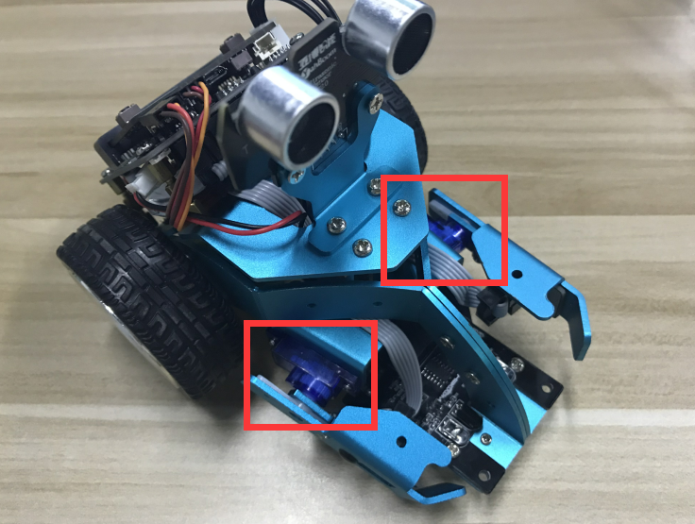
5-1-1 servos on arm of hellobot
Tow servos is the robot's joint, which is mounted on the two arms of the HelloBot. You can control servos rotate degree to control arms.
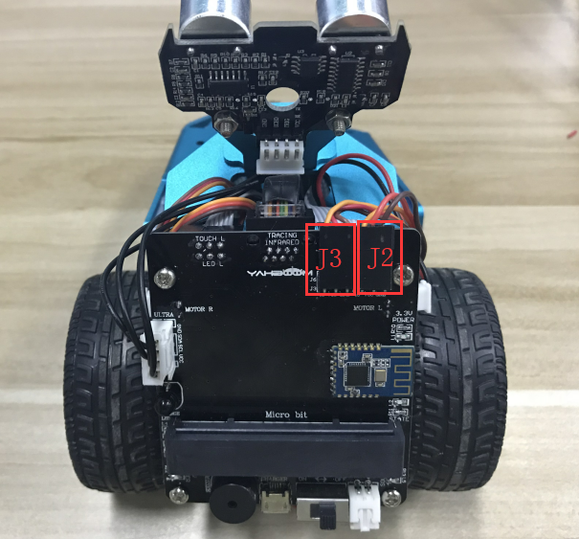5-1-2 about wiring

You need to look forward from the back of the robot, the left servo is connected to the J3 interface, and the right servo is connected to the J2 interface. The brown line of the servo corresponds to GND, the red line corresponds to VCC, and the yellow line corresponds to IO.

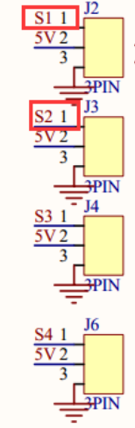
5-1-3 schematic of servo
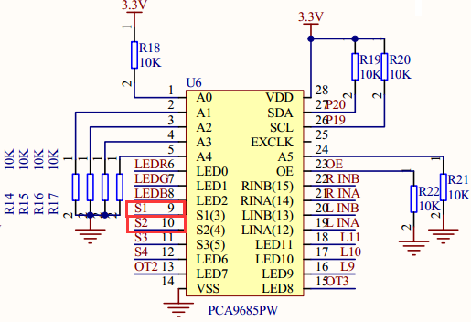
5-1-4 schematic of PCA9685PW
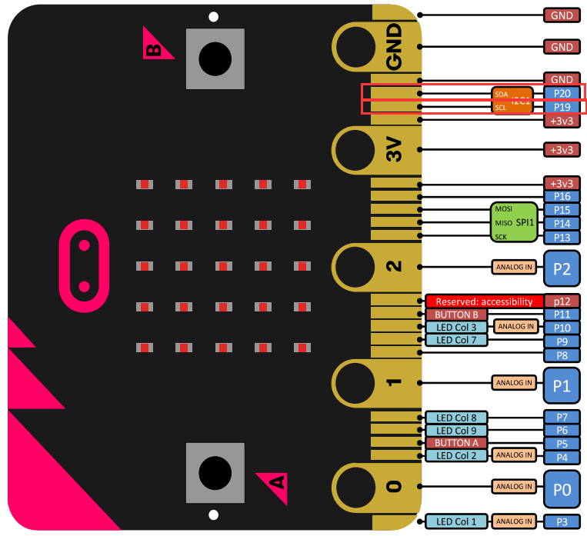
5-1-5 Pins of Micro:bit
From the schematic diagram in5-1-3,P5-1-4.You can see that left servo is connected to s1 of PCA9685PW,right servo is connected to s2 of PCA9685PW.
PCA9685PW is a 16-bit LED controller with IIC bus interface. Each LED can output 12-bit resolution (4096 levels) fixed-frequency independent PWM. It only needs to write the corresponding PWM register value, S1 and S2 interface will output PWM signal to drives the servo.
(You need to look forward from the back of the robot to distinguish between left and right.)
Note:In the bottom layer of the HelloBot package has been set parameter for the user, you can directly drag the arm building blocks.
- Learning goals
In this course, we will learn how to control arm by driving servo. When you press “A” key, left arm of HelloBot will go up and then go down.When you press “B” key, right arm of HelloBot will go up and then go down.
3.Programming
3.1 Programming online
You can enter the URL directly in your browser: http://python.microbit.org/v/1 to enter programming online interface.
3.2 Programming offline
1) You can double-click to use it. As shown in the following figure.
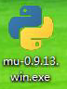
2) After entering the programming interface.
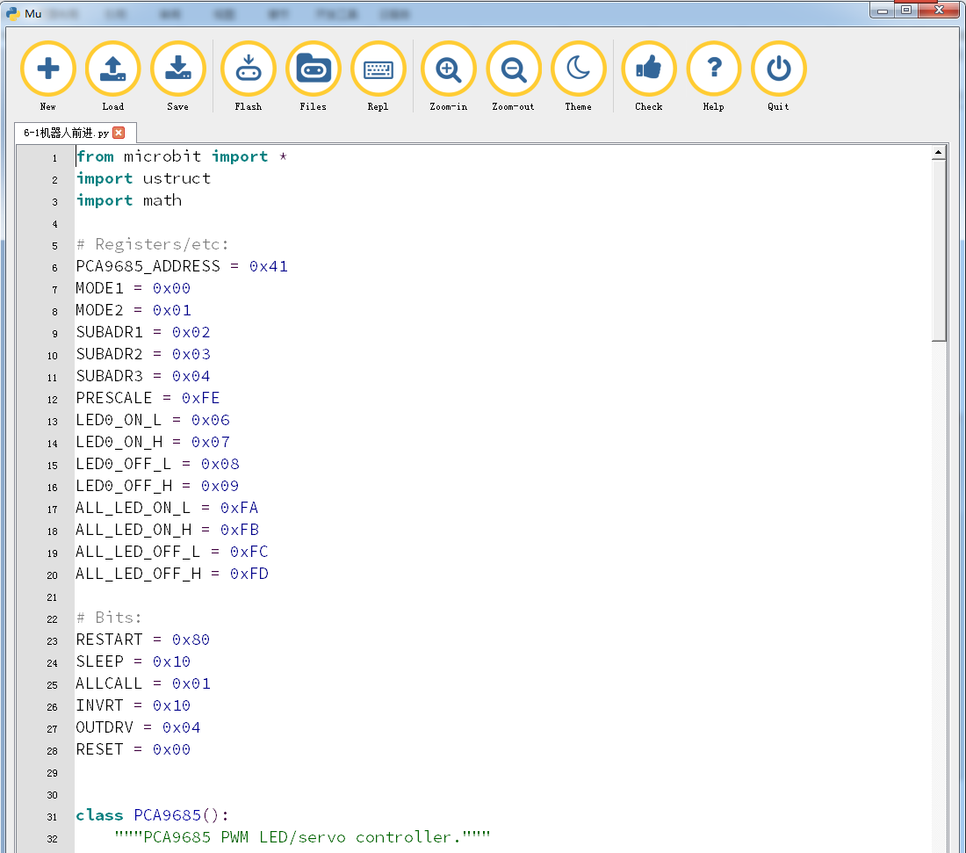
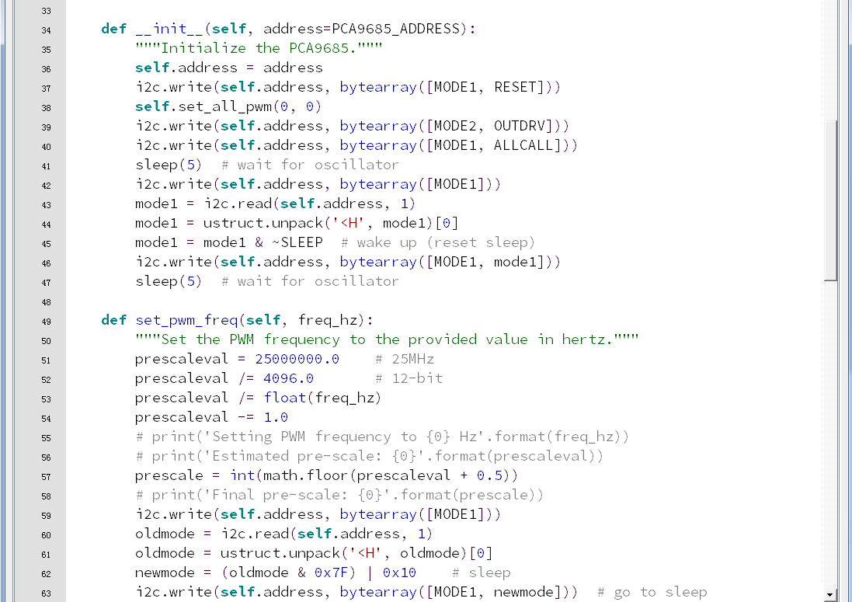
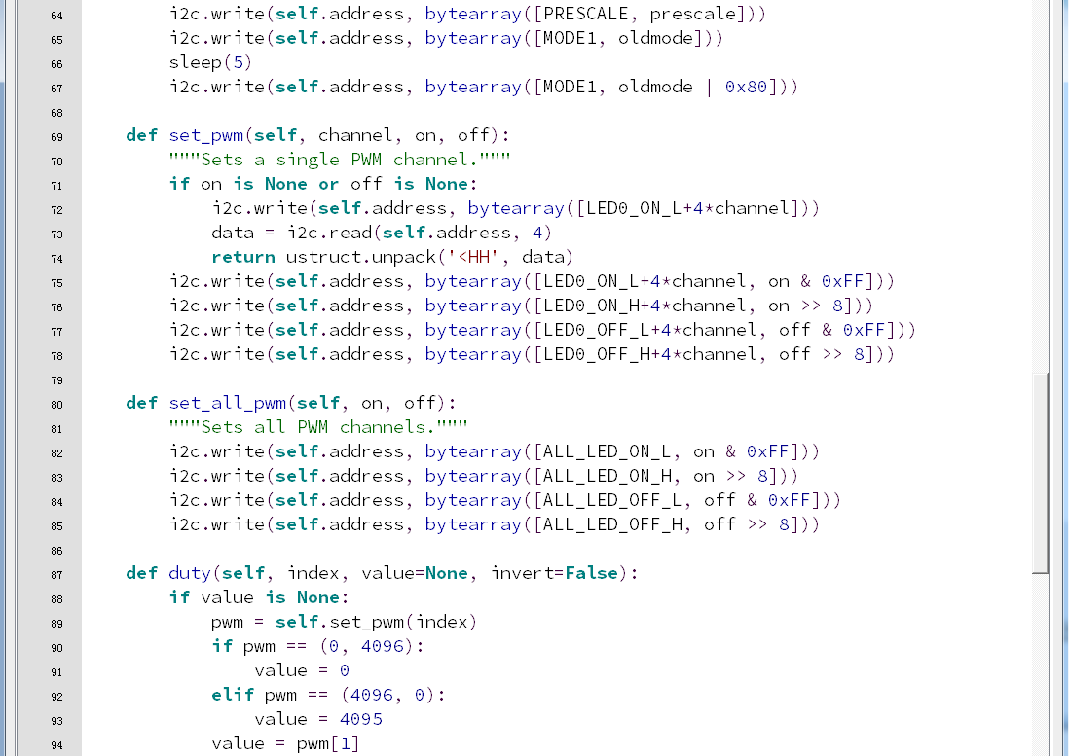
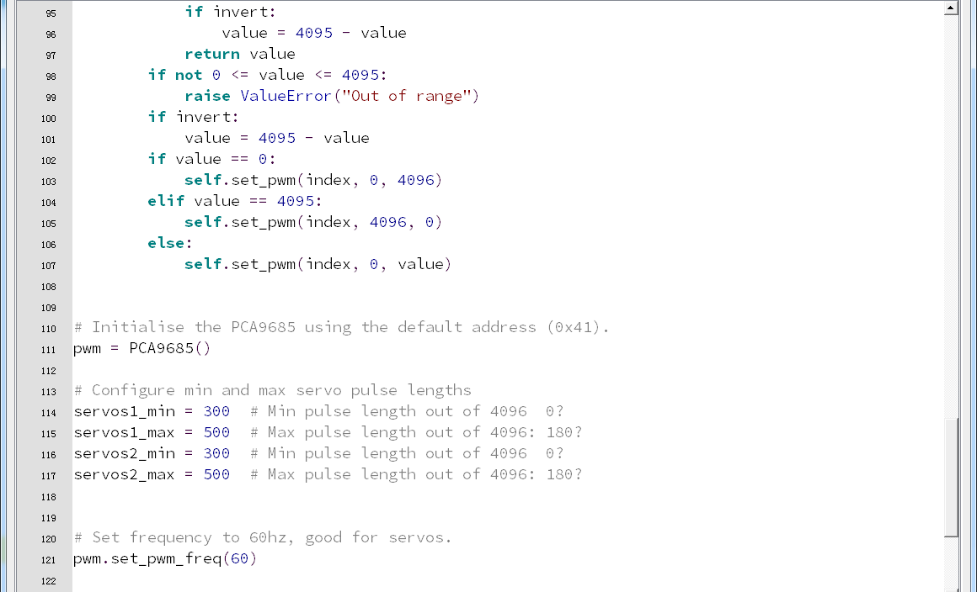
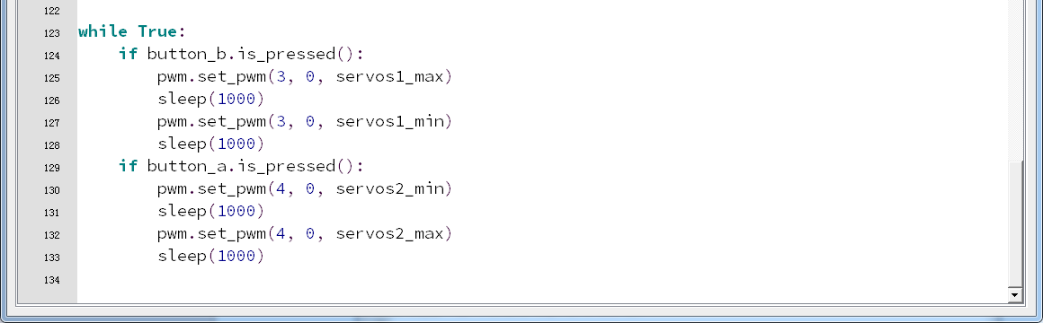
5-1-6
Note:
1 - The capital letter / lowercase letters must be distinguished！
2 - Correct spelling!
3 - Keywords such as # need a space between the content.
4 - The program ends with a blank program.
5 - The block body (such as the body of the while is marked by indentation), compared to the C language, Python completely eliminates the braces (along with the semicolon of the suffix), and uses the indentation structure to represent the relationship. You can only use the Tab key (tabulation key) for indentation.

4.Download programming
You need to make sure that the micro:bit development board is connected to the computer and you need to click “Flash” button.
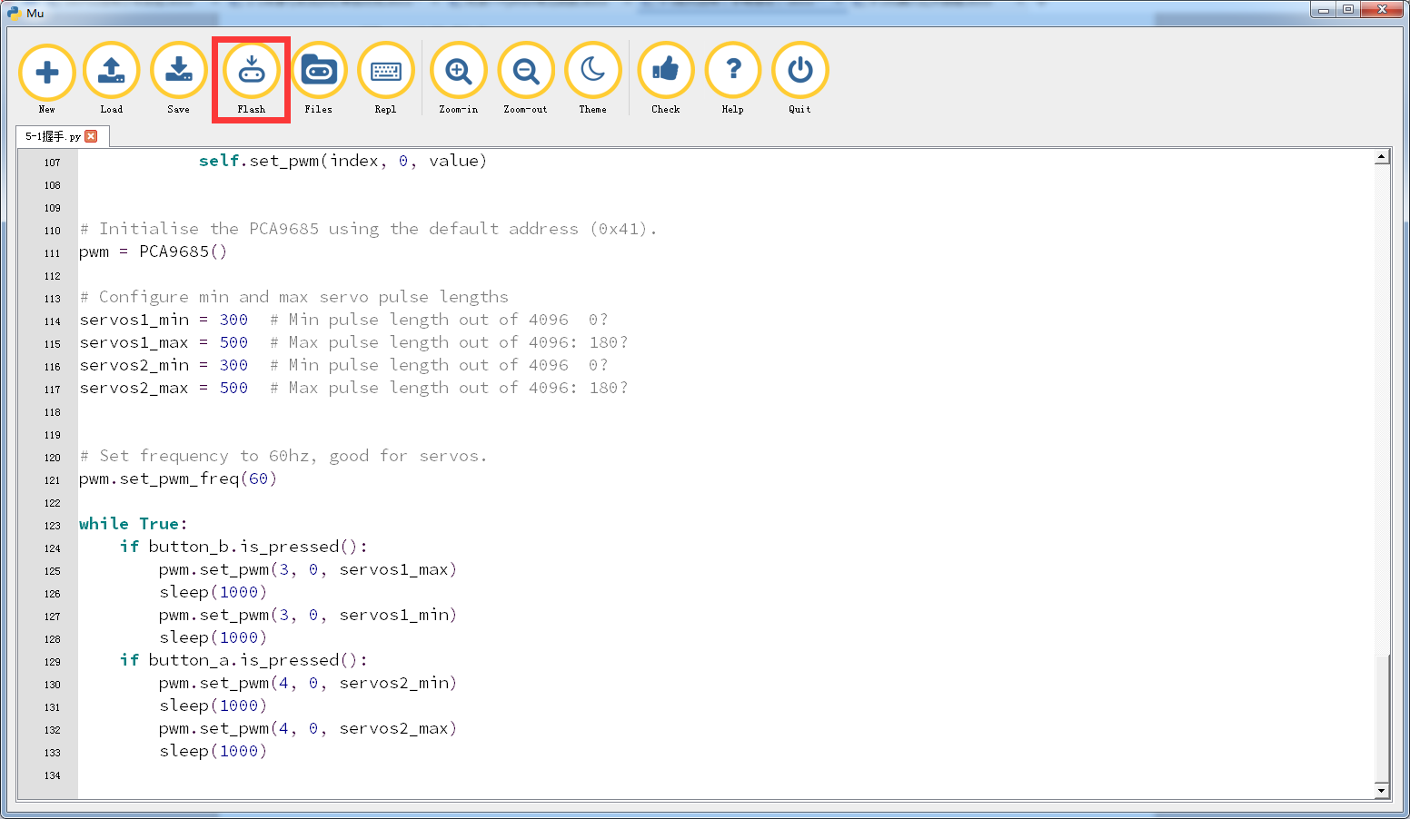
5-1-7
5.Phenomenon
After the code is uploaded. When you press “A” key, left arm of HelloBot will go up and then go down.When you press “B” key, right arm of HelloBot will go up and then go down.
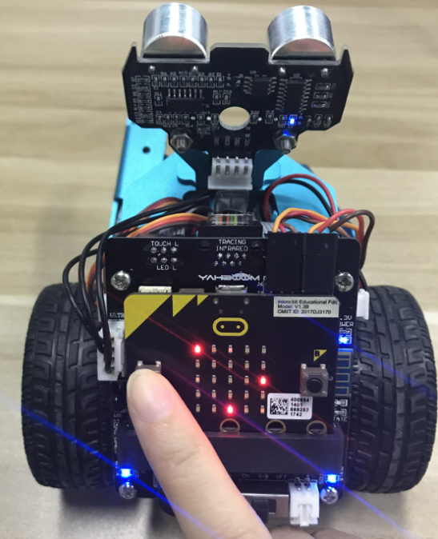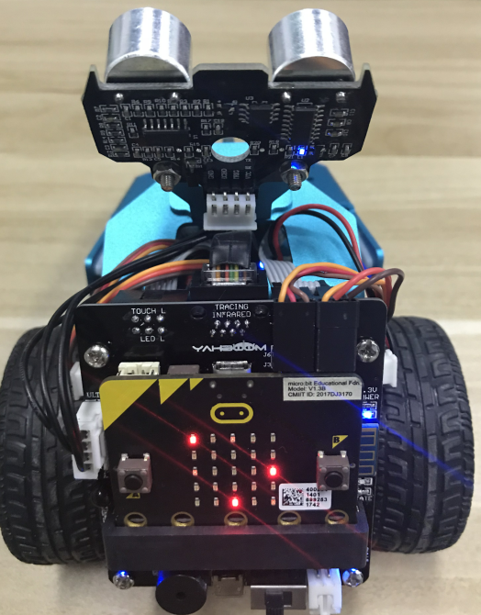
(a) (b)
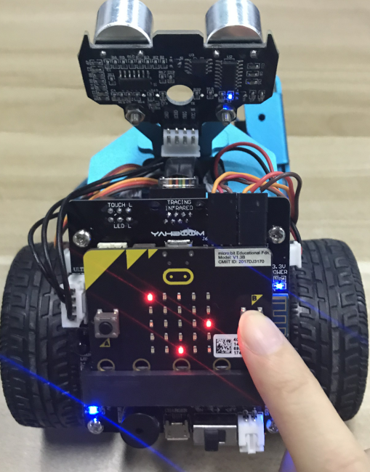
(c) (d)
5-1-8

